INTRODUCTION

Creating Positive Social
Outcomes for Whittlesea Residents

Whittlesea Community Futures Partnership

The Whittlesea Community Futures Partnership (WCF) is a partnership of 45 multidisciplinary agencies including the City of Whittlesea, State and Federal Government Departments, Human Service Organisations, and Community Based Organisations. The WCF Partnership is a united cross sector planning and advocacy body working to improve the well-being of local communities. The WCF Partnership focuses on issues impacting on families, children, young people, culturally and linguistically diverse (CALD) communities, disabled and ageing residents.

The City of Whittlesea
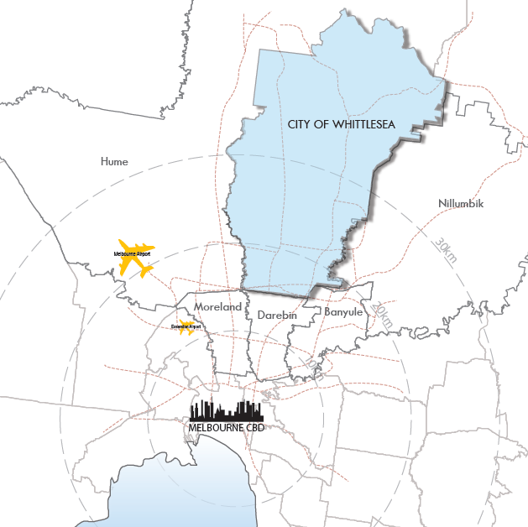
The City of Whittlesea is located on Melbourne’s metropolitan fringe, 20km north of the CBD. It is a large municipality of 490 square kilometres with established urban, growth and rural areas. The City includes the rural centre of Whittlesea, the rural localities of Beveridge, Donnybrook, Eden Park, Humevale, Kinglake West, Wollert, Woodstock and Yan Yean as well as the established and growing urban suburbs of Bundoora, Doreen, Epping, Lalor, Mernda, Mill Park, South Morang (including Quarry Hills) and Thomastown.
Population Growth

The City of Whittlesea is:
- the third fastest growing municipality in Victoria
- the second largest growing municipality in Victoria (in raw numbers: +8,194 new residents in 2012)
- the sixth largest municipality in Australia
- designated by the Victorian State Government as a growth area of metropolitan significance.

The population is expected to reach 297,151 by 2030. Growth is concentrated in the developing areas of Mernda-Doreen, South Morang, Epping North, Wollert and Donnybrook. The City’s current population of approximately 176,595 is expected to grow by 41% over the next ten years.

The Wurundjeri Willum Clan are the traditional owners of this land. Today the City of Whittlesea has the fourth highest Aboriginal population in metropolitan Melbourne.

Challenges

Melbourne has been given the title of the ‘most liveable city in the world’, but that is only true for the more advantaged parts of the city. In contrast, the outer suburbs of Melbourne, home to our newest communities, face serious liveability challenges. These have been highlighted by Parliamentary reports in the past year and by the Victorian Auditor General.

As a Council at the interface of urban and rural areas, Whittlesea is characterised by demographic and geographic challenges.

 | City of Whittlesea | Greater Melbourne
Median age | 34 years | 36 years
Aged below 15 years old | 21% | 19%
Aged 50 years old and above | 27% | 30%
Born in Non-English speaking country | 32% | 26%
Speak languages other than English | 43% | 29%
Couples with children | 43% | 34%
Median weekly household income | $1,275 | $1,333
Housing structure - separate house | 92% | 79%
Source: ABS 2011 Census data, published by Profile.id (2013)

These challenges raise the following issues in relation to Whittlesea and to this submission:

- Services and infrastructure are not keeping up with population growth
- Transport infrastructure is seriously lacking
- Social disconnection

- Services and infrastructure are not keeping up with population growth

Melbourne’s growth area councils have accommodated a disproportionate amount of Melbourne’s population growth and this has placed significant pressure on existing infrastructure and created strong demand for new infrastructure, which has not been met and should be addressed as a matter of urgency.

The rapid population growth in the City of Whittlesea has not been matched by public investment in the services and infrastructure that every community needs for its residents’ health and wellbeing, and that inner Melbourne residents take for granted.
Vulnerable new communities consisting largely of families with young people and children are becoming isolated and experiencing high rates of physical and mental health issues that are directly related to a lack of support in health, education, and community services and infrastructure.

The majority of Melbourne’s medical and health services are located in established areas close to Melbourne’s CBD. Although only 20% of the population live within ten kilometres of the CBD, over 40% of health care providers are based in this area. This is the case for both public and private hospitals, as well as metropolitan health services.

A recent survey of local human service organisations revealed that they cannot meet the demand for their services. Of the agencies surveyed in the City of Whittlesea:

- 84.6% have experienced a significant increase in demand for services
- 76.9% are unable to respond to this increase in demand
- 84.6% need to maintain waiting lists for services
- 61.5% have difficulty referring clients due to lack of capacity
- Residents’ access to services is limited by location and a lack of adequate public and community transport.

- Transport infrastructure is seriously lacking

Inadequate public transport and growing gaps in the road network in these communities are creating barriers to mobility, including access to critical services, education and employment opportunities.

Far too many residents in Whittlesea’s new communities experience significant disadvantage because of the lack of transport infrastructure and services (road, rail and bus). This increases car dependency that:

- affects physical health and wellbeing
- increases vulnerability to financial stress due to rising petrol and associated car costs
- undermines the quality of time people have with their families and friends
- results in dormitory suburbs
- is detrimental to the environment.

A recent Victorian Auditor-General’s report found that Whittlesea had a backlog of between $630-730 million that needs to be spent on improving Whittlesea’s road infrastructure.

Case study in public transport planning and funding deficiencies: The Aurora Estate, Epping North

Epping North is 20km north of Melbourne's CBD and covers approximately 668 hectares. It is one of Victoria’s largest integrated urban developments, and will house around 55,000 people within 20 years. Approximately 20,000 of these residents are located in the Aurora Estate, which is around one-third complete. It is expected to have over 8,000 homes by 2020.

The precinct was identified as a growth area in Melbourne 2030.

An extension of the rail line to Epping North to serve Aurora was proposed in 2002.Aurora Estate was marketed by the State as a master-planned community in a well-connected location and environment.

The sales brochures stated that 'most homes will be within 200 metres of a park, 400 metres of a bus stop and 800 metres of a school and local shops'.

Despite people having bought homes in the area on this basis, public transport services are still inadequate. Only around 40 per cent of homes are within 400 metres of bus stops and there is only one route near the estate.

- Social disconnection

Whittlesea residents are vulnerable to social isolation because of the location of the City’s outer suburbs - in the gap between middle and rural suburbs - and the newness of many of the growing outer suburbs. A lack of public transport, car dependence, greater distances to employment, and new communities, have all been identified as contributing to social isolation in Melbourne’s outer suburbs.

This Inquiry recommends that the Victorian Government collaborates with the Interface Councils to provide resources to boost social cohesion and reduce socio-spatial polarisation within Melbourne’s outer suburbs.

The high numbers of young people living in Whittlesea’s growth areas are particularly vulnerable to becoming disconnected from their local community. There is a lack of local schools to foster feelings of connection and belonging to the local community, limited recreational opportunities and a lack of early intervention community support services and infrastructure. This all contributes to the area’s high rates of youth disengagement from education and employment.

It is recommended that the Victorian Government work with the Interface Councils to target the provision of additional youth and children’s infrastructure to the outer suburbs.

Statistical overview – City of Whittlesea compared to the rest of Melbourne
Indicator | City of Whittlesea | Greater Melbourne | Trend in relation to Greater Melbourne
Population growth (2011-2012) | 5.4% | 1.9%
Jobs to population ratio | 25.4% | 43.9%
Jobs in education and training, healthcare and social assistance, arts and recreation to population ratio | 6.1% | 9.6%
Completed Year 12 | 47.5% | 54.6%
No post-secondary qualifications | 51.4% | 42.4%
Unemployment* | Whittlesea –  North 8%  South-East 4.8%  South-West 10.6% | 5.6%
Mortgage Stress | 15.9% | 11.0%
Disengaged Youth | 9.2% (Lalor 14.5%, Thomastown 12.8%, Epping 12.0%) | 7.4%
Rate of family violence (per 100,000 population)^ | 1249 | 1071 (Vic)
Birth rate** (births per 1,000 women aged 15-44) | 65 | 58
Adults who rate their health as excellent or very good# | 34.4% | 46.6% (Vic)
Adults overweight or obese# | 55.4% | 49.8% (Vic)
Rate of Type 2 Diabetes# | 7.1% | 4.8% (Vic)
Adults reporting a high/very high level of psychosocial distress# | 13.6% | 11.1% (Vic)
Lack of time for family and friends~ | 36.3% | 27.4%

Snapshot comparison

Resident of inner Melbourne | Resident of an Interface  suburb or township | Social Outcomes  for Interface residents
Existing kindergartens and pre-schools in close proximity | Fewer options for kindergarten and preschool at greater distances | Lower rates of pre-school attendance leading to child developmental delay and less opportunity for early intervention
Existing primary, secondary and higher education facilities in close proximity | Relative lack of primary, secondary and higher education facilities | Higher rates of disengagement from education and lower educational qualifications.
Existing medical facilities and community support services in close proximity | Lack of adequate medical facilities and community support services | Higher rates of physical and mental health issues including increased drug and alcohol abuse and higher rates of violent crime
Multiple options for recreation and a variety of community facilities and services | Lack of adequate recreation options and very limited community facilities and services | Lower rates of physical activity leading to health issues and lower rates of community connection and participation
Many employment opportunities in relative close proximity | Few local employment opportunities | Higher unemployment rate and those employed are at a greater distance from their place of work.
Multiple transport options including very well linked-up public transport and road networks | Limited transport options including inadequate public transport and road networks | Long commute times lead to increased travel costs and less time available for family and community activities which impacts on quality of life.

Parliamentary Inquiry into Livability Options in Outer Suburban Melbourne, State Parliament of Victoria, December 2012, p128
Ibid, p468
Victorian Auditor-General, Developing Transport Infrastructure and Services for Population Growth Areas, Parliamentary Paper No 249, Session 2010-13, State Government of Victoria
Inquiry into Liveability, P 340
P 172
p111
The information here is taken from “One Melbourne or Two? An overview prepared by Interface Councils.”, February 2013

